Title: ARIAL 11 BOLD

Author(s), Co-Authors (if applicable): Arial 11 Italic
Keywords (3 to 5):

Abstract:
Arial 11

Text of the proposal (Max 3000 words):
Arial 11

References:
- Smith, Z. (2017) Swing time. London: Penguin.
- Thagard, P. (1990) ‘Philosophy and machine learning’, Canadian Journal of Philosophy, 20(2), pp. 261-276.
- Google (2019) Google terms of service. Available at: https://policies.google.com/terms?hl=en-US (Accessed: 27 January 2020).

Short biographical statement of the author(s) (max 60 words):
Arial 11

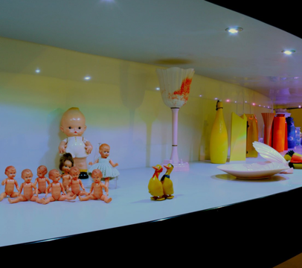
Figure 1. The permanent exhibition © Fondazione Plart (photo: Fabio Donato).

